LABWORK – 3
Variables declaration in R
- Declaring a variable of type “numeric”
> myVariable <- numeric() # Creating a numeric variable
> class(myVariable)
[1] "numeric"
> myVariable1 = as.numeric()
> class(myVariable1)
[1] "numeric"

- Declaring a variable of type “character”
> myVariable2 <- character() # Creating a character variable
> class(myVariable2)
[1] "character"
> myVariable3 = as.character()
> class(myVariable3)
[1] "character"

- Declaring a variable of type “logical”, “complex” & “integer”
> myVariable4 = as.logical ( )  > class (myVariable4)  [1] "logical" | > myVariable7 <- logical ( )  > class (myVariable7)  [1] "logical"
> myVariable5 = as.complex ( )  > class (myVariable5)  [1] "complex" | > myVariable8 <- complex ( )  > class (myVariable8)  [1] "complex"
> myVariable6 = as.integer ( )  > class (myVariable6)  [1] "integer" | > myVariable9 <- integer ( )  > class (myVariable9)  [1] "integer"

Variables assignment in R
- Assigning a decimal value to a variable
> myVariable = 3.14
> class (myVariable)
[1] "numeric"

- Assignment of an integer value
> myInteger = as.integer (1)
> myInteger
[1] 1
> class (myInteger)
[1] "integer"

- Assignment of a complex number
> z = 2+3i
> class (z)
[1] "complex"

- Assignment of a logical value
> myMoodIsHappy = TRUE
> class (myMoodIsHappy)
[1] "logical"
> !myMoodIsHappy
[1] FALSE

- Assignment of an integer value
> myName = "beu"
> class (myName)
[1] "character"

Data type of a variable in R
> myVariable  [1] 3.14  > typeof (myVariable)  [1] "double | > x <- as.numeric()  > typeof(x)  [1] "double"
> typeof(TRUE)  [1] "logical" | > typeof(1)  [1] "double"
> typeof(0)  [1] "double" | > typeof(0L)  [1] "integer"
> typeof(0i)  [1] "complex" | > typeof("beu")  [1] "character"

Listing all variables
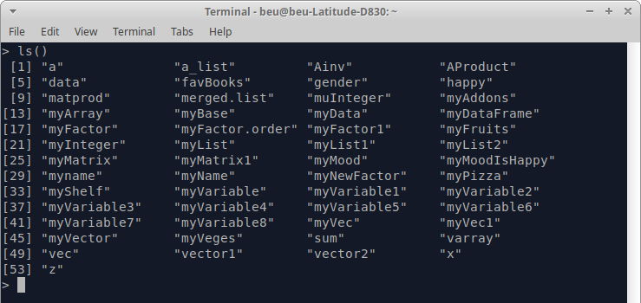
Listing all variables which contain the word “Variable”
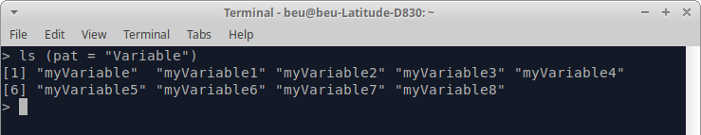
Listing all variables which contain “ . ”
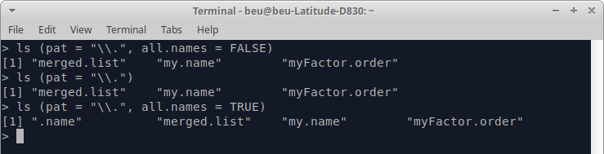
# all.names – is a logical value. If it is TRUE, all object names are returned. If FALSE, names which begin with a . are omitted.

Deleting variables in R
> favBooks
[1] "Discrete_Mathematics" "Linear_Algebra"
[3] "Graph_Theory" "Mathematical_Statistics"
[5] "Abstract_Algebra" "Algorithm_Design"
[7] "Computer_Networking"
> remove (favBooks) # using remove
> favBooks
Error: object 'favBooks' not found

> myData
[1] 1 2 2 4 6 3 1 2 3 4 6 6 1 3 1 2 3 3 1
> rm (myData) # using rm
> myData
Error: object 'myData' not found

> rm(list = ls()) # removes all objects from the current workspace
> ls()
character(0)

Relational Operators in R
FUNCTION | R EXPRESSION | WORKING EXAMPLE
Equality | == | > x = 7  > x == 7  [1] TRUE  > x == 3  [1] FALSE
Inequality | != | > y = -3  > y != -3  [1] FALSE  > y != 4  [1] TRUE
Less than | < | > 5 >2  [1] TRUE  > 5 > 5  [1] FALSE  > 5 > 10  [1] FALSE
Greater than | > | > 5 < 2  [1] FALSE  > 5 < 5  [1] FALSE  > 5 < 10  [1] TRUE
Less than or equal to | <= | > a = 10  > b = 5  > a <= b  [1] FALSE
Greater than or equal to | >= | > a = 1  > b = 0  > a >= b  [1] TRUE

Logical Operators in R
FUNCTION | R EXPRESSION | WORKING EXAMPLE
Logical NOT | ! | > myMoodIsHappy  [1] TRUE  > ! myMoodIsHappy  [1] FALSE
Element-wise logical AND | & | > TRUE & TRUE  [1] TRUE  > TRUE & FALSE  [1] FALSE  > FALSE & FALSE  [1] FALSE  > FALSE & TRUE  [1] FALSE
Element-wise logical OR | | | > TRUE | TRUE  [1] TRUE  > TRUE | FALSE  [1] TRUE  > FALSE | TRUE  [1] TRUE  > FALSE | FALSE  [1] FALSE
Logical AND | && | > x <- c(TRUE, FALSE, FALSE)  > y <- c(FALSE, FALSE,FALSE)  > x && y  [1] FALSE
Logical OR | | | | > x <- c(TRUE, FALSE, FALSE)  > y <- c(FALSE, FALSE,FALSE)  > x | | y  [1] TRUE

Assignment Operators in R
FUNCTION | R EXPRESSION | WORKING EXAMPLE
Leftwards assignment | <-, <<-, = | > myNum <- 7  > myNum  [1] 7  > myNum1 = 10  > myNum1  [1] 10  > myNum2 <<- 13  > myNum2  [1] 13
Rightwards assignment | ->, ->> | > 1 -> newNum1  > newNum1  [1] 1  > 2 ->> newNum2  > newNum2  [1] 2

